Assignment -9.4 K.Dhana sri b-41 htno:2303a52153
Task 1:
Auto-Generating Function Documentation Scenario Existing utility functions lack documentation, making onboarding difficult. Original code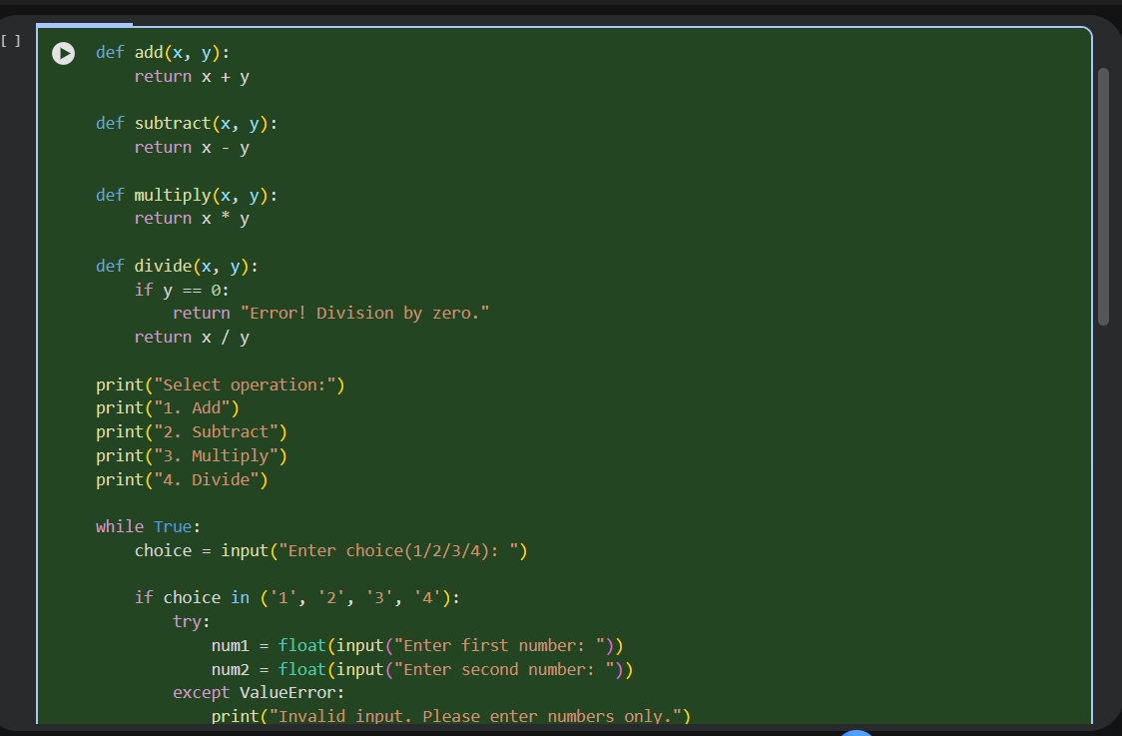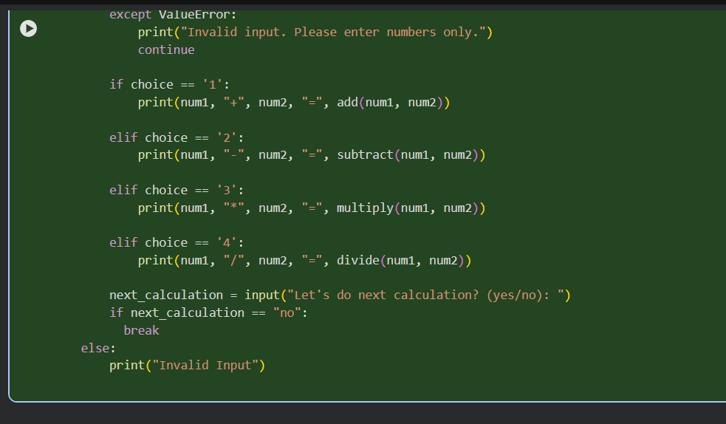
Prompt Used (Zero-Shot Prompt) Generate Google-style docstrings for the following Python functions. Include description, parameters, return values, and example usage. AI-Generated Code With Google-Style Docstrings:
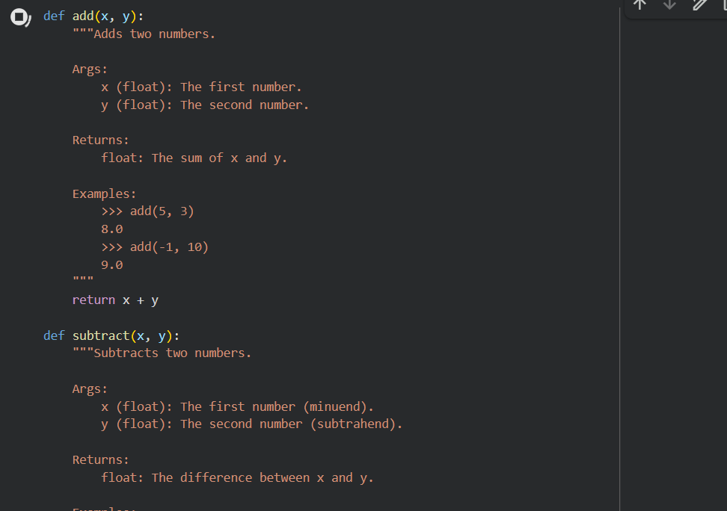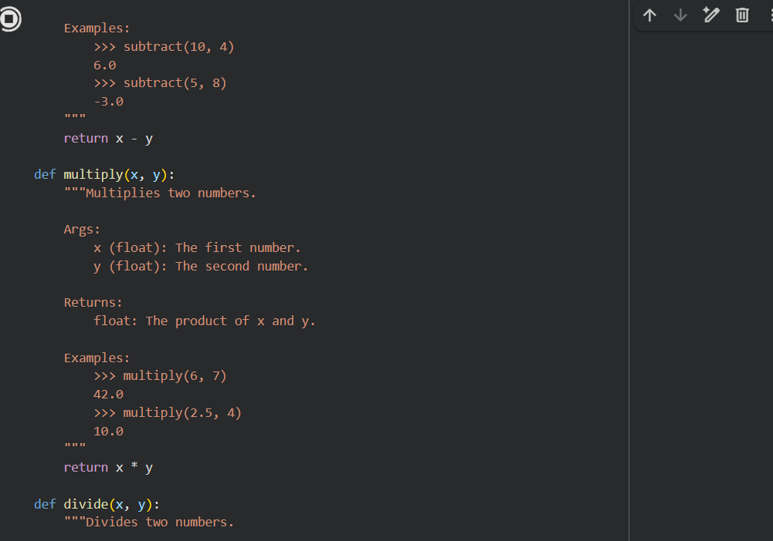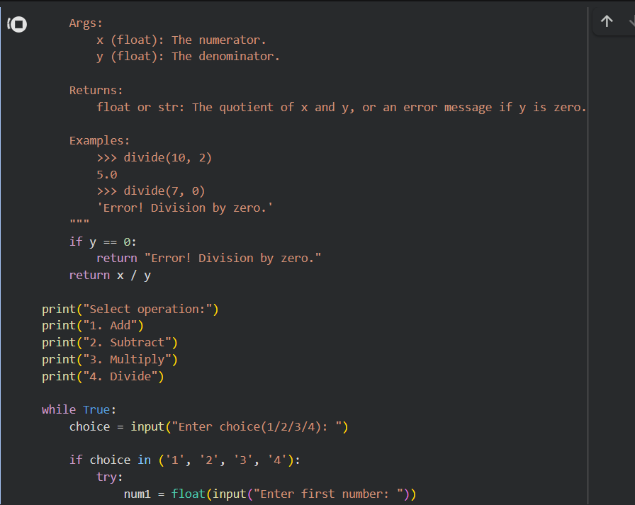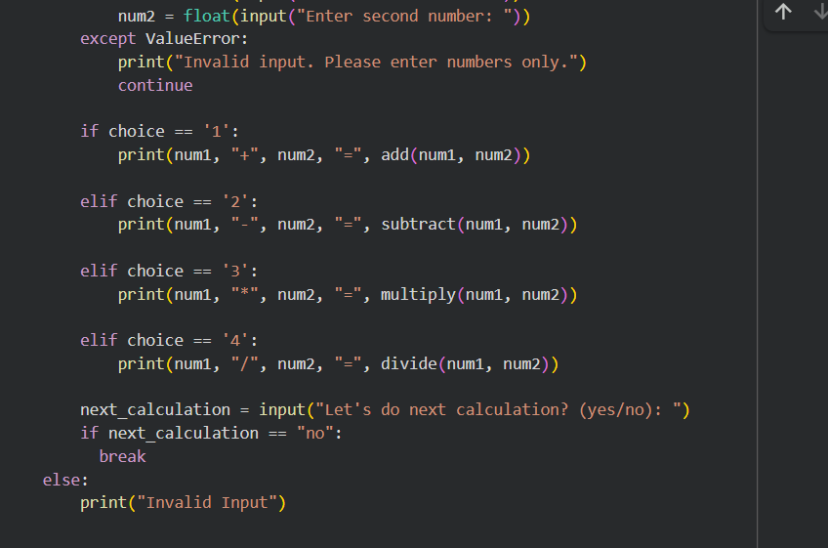
Explanation In this task, AI assistance is used to automatically generate Google-style function docstrings for an existing Python codebase that lacks documentation. The objective is to improve code understandability for new developers. A zero-shot or context-based prompt is given to the AI without providing examples, asking it to analyze the function logic and generate structured docstrings. The AI inspects the function behavior, identifies parameters, return values, and usage patterns, and produces standardized documentation. This task demonstrates how AI can quickly transform undocumented code into a readable and professional codebase, reducing onboarding time and improving API clarity without modifying the actual logic.
Task 2: Enhancing Readability With Inline Comments Scenario Working logic exists but is difficult to understand.
Orginal code:
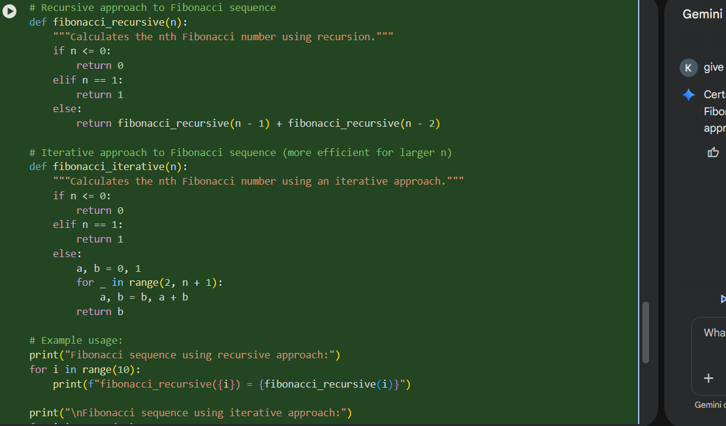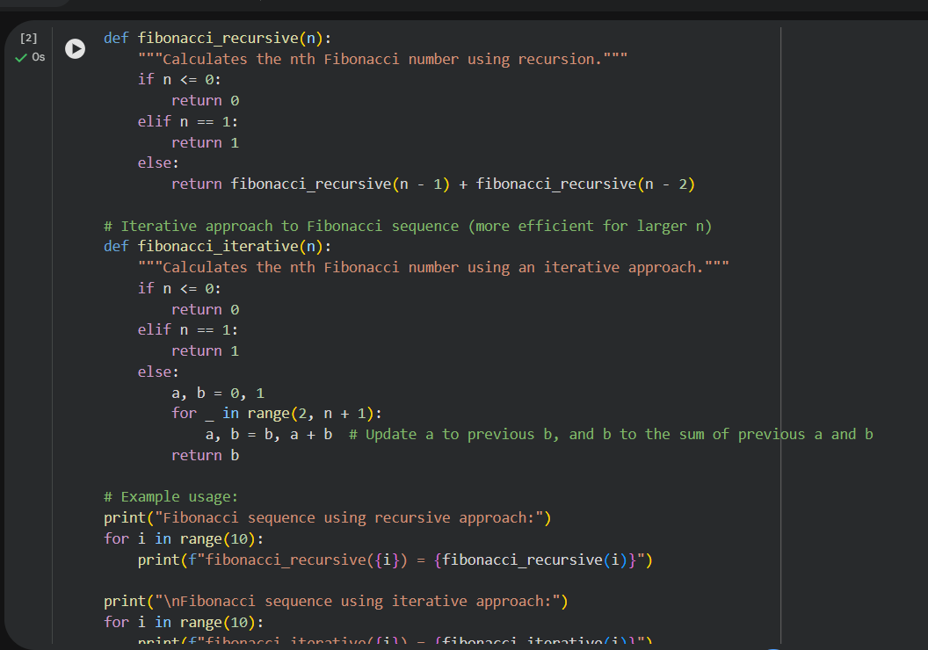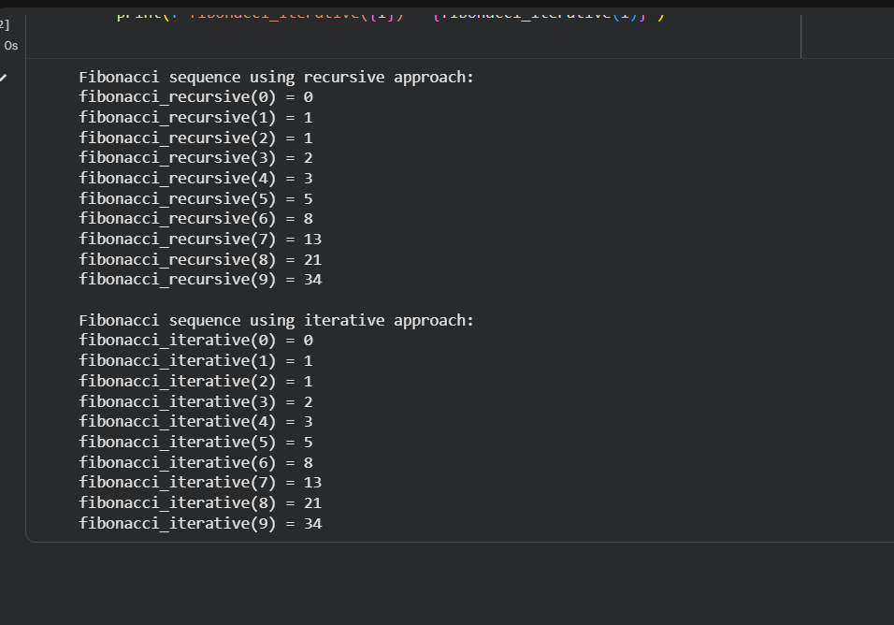
Explanation:This task focuses on improving code readability by inserting meaningful inline comments only where the logic is complex or non-obvious. Using AI assistance, the code is analyzed to identify sections such as algorithmic updates, loop behavior, or value transformations that may confuse future maintainers. Comments are added selectively at these points. This task highlights the importance of clean commenting practices and shows how AI helps prevent over-commenting while still improving maintainability and debugging efficiency.
Task 3: Module-Level Documentation Scenario Python module is being prepared for internal reuse or repository upload.
Python module code:
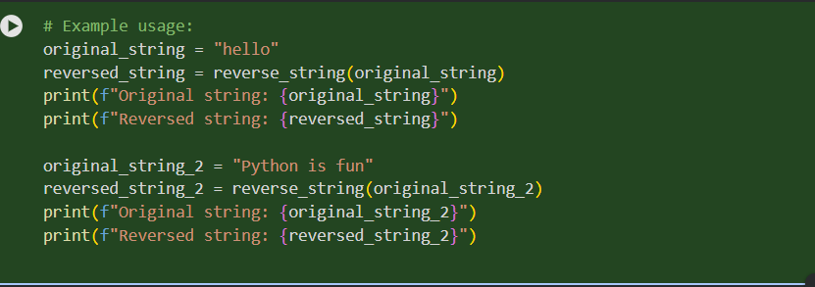
prompt Used:
Generate a professional module-level docstring explaining purpose, dependencies, key functions, and example usage. AI-Generated Module-Level Docstring
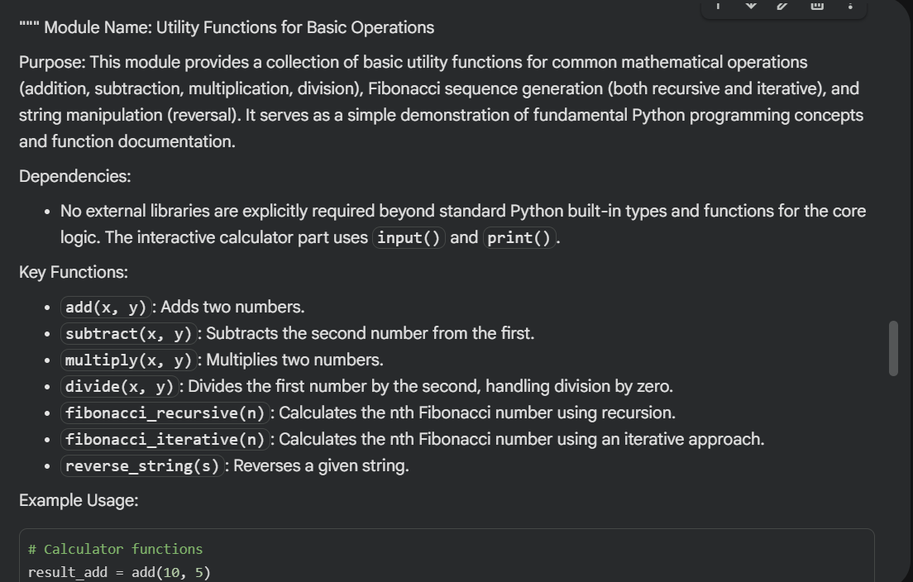
Explanation In this task, AI is used to generate a module-level docstring that appears at the top of a Python file. This documentation provides a high-level overview of the module’s purpose and structure. The AI analyzes all functions and imports in the module and generates a professional, multiline docstring describing:
• The purpose of the module

• Dependencies used
• Key functions or classes
• Example usage This task ensures that anyone opening the file can immediately understand what the module does, making it suitable for real-world projects and shared repositories.
Task 4: Converting Developer Comments into Docstrings Scenario Legacy code contains long comments instead of docstrings.
Original code:
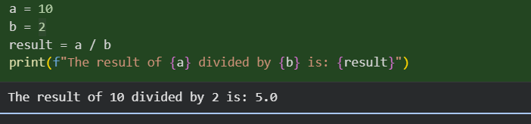
Prompt Used
Convert inline developer comments into a structured Google-style docstring and remove redundant comments.
Converted code
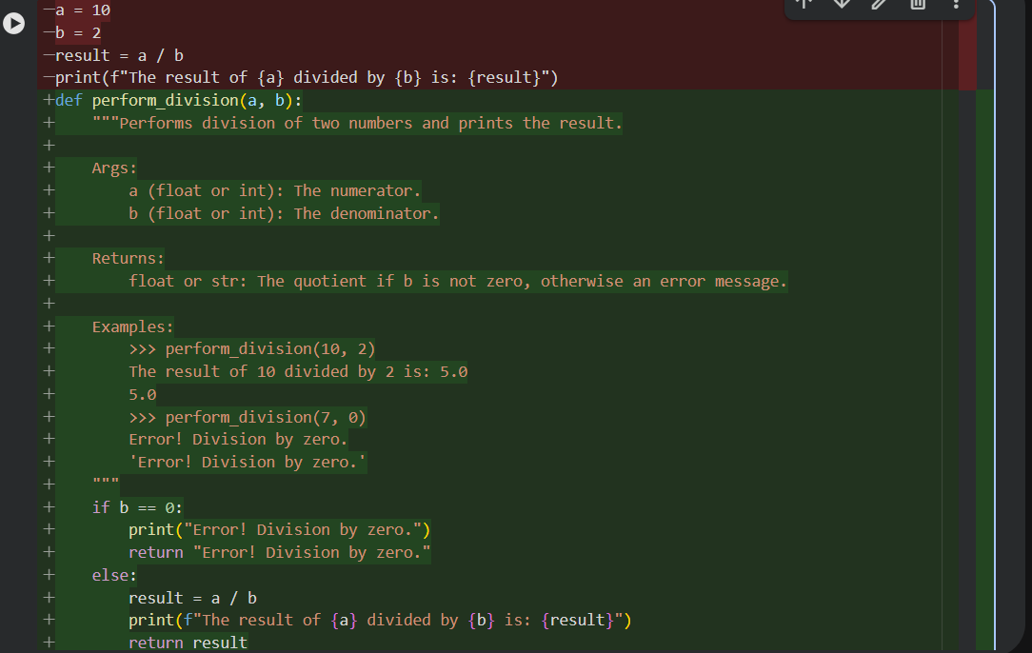
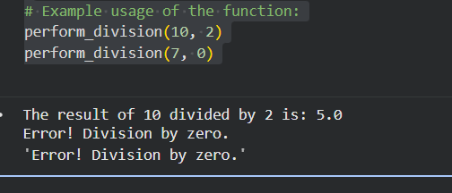
Explanation :
This task addresses legacy code where developers have written long explanatory comments inside functions instead of proper docstrings. Such comments increase clutter and break documentation standards. AI assistance is used to extract the intent of these inline comments and convert them into structured Google-style or NumPy-style docstrings. After conversion, redundant inline comments are removed, keeping the function body clean. This task demonstrates how AI helps in documentation standardization, improves consistency across the codebase, and aligns old projects with modern Python best practices.
Task 5: Building a Mini Automatic Documentation Generator Scenario Your team wants a simple internal tool that helps developers start documenting new Python files quickly, without writing documentation from scratch.
Python utility script:
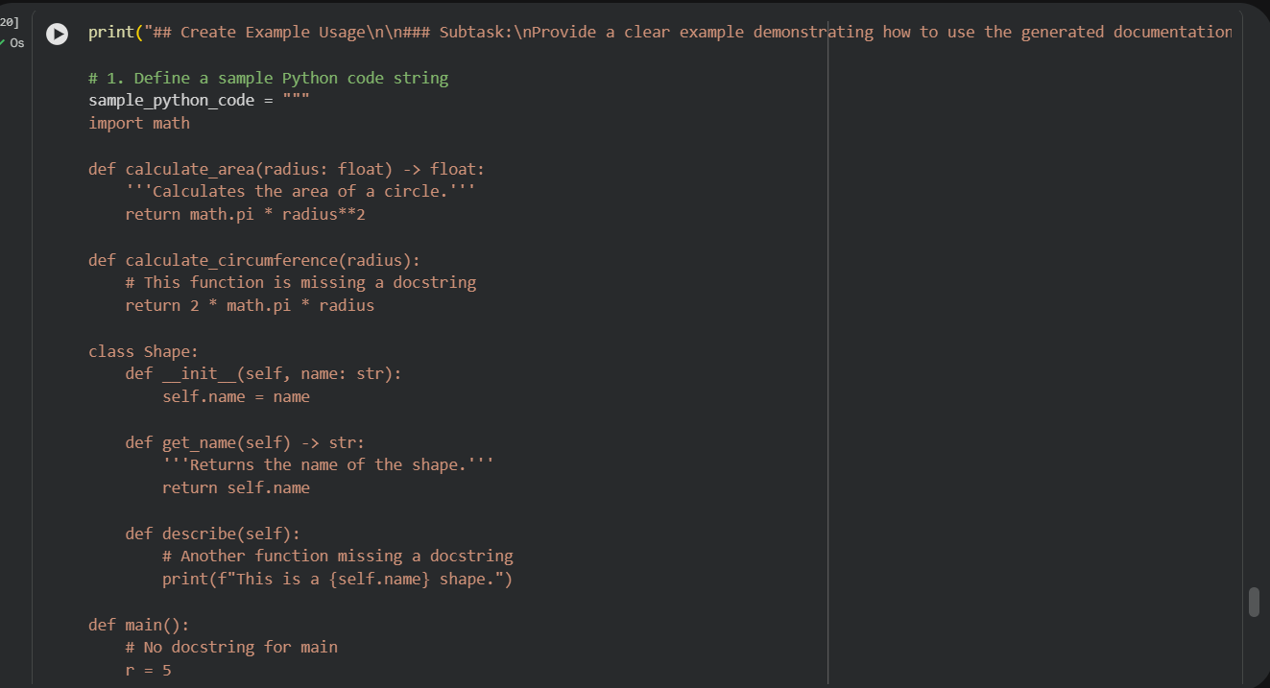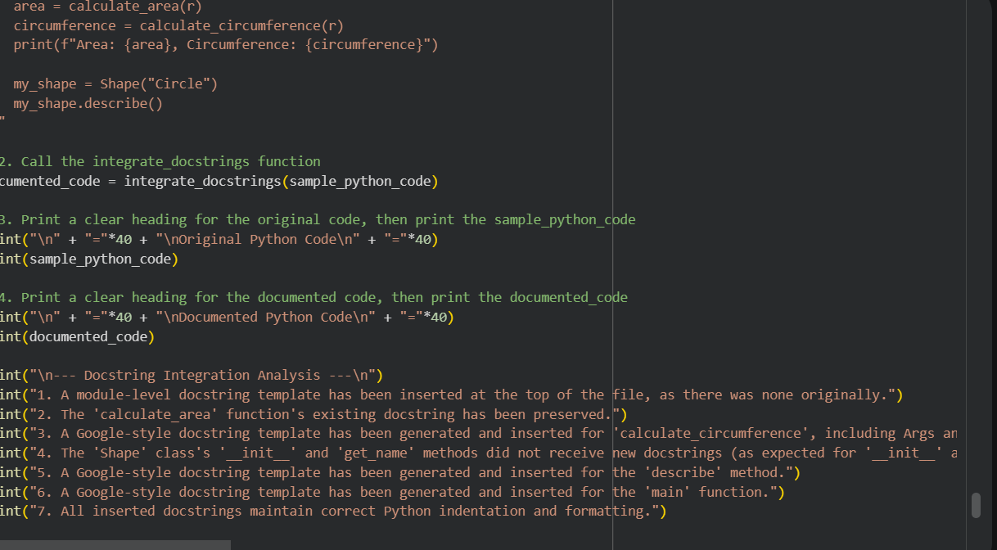
Output Example:
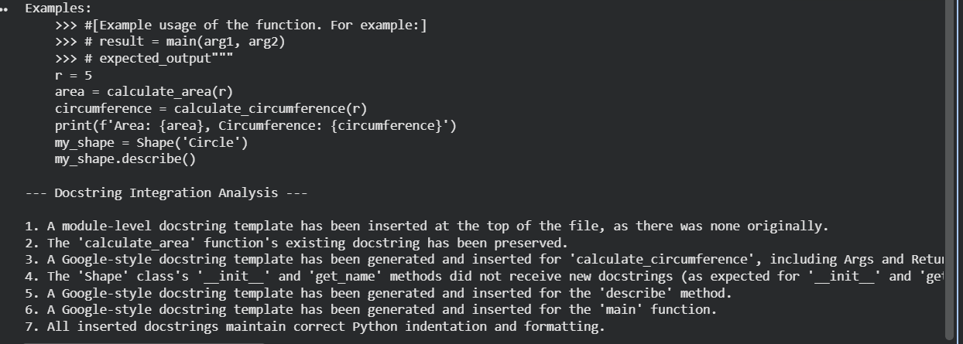
Explanation :
In this task, a small Python utility is designed to automatically detect functions and classes in a given .py file and insert placeholder docstrings. The script uses Python’s ast (Abstract Syntax Tree) module to parse the source file and identify code structures without executing it. For each detected function or class, the tool generates a basic Google-style documentation template. This task shows how AI and automation can assist developers by providing documentation scaffolding, allowing them to focus on logic while maintaining documentation discipline from the start.
+

